COMMUNITY SERVICE PROJECT ON

HEALTH AND HYGIENE

A project report on submitted in partial fulfilment of the requirements for award of the Degree of

BACHELOR OF TECHNOLOGY In DATA SCIENCE

SUBMITTED

BY:

K.S.L. Pavani 20KP1A4415

T. Vishnu Vardhan 20KP1A4456

Ch. Sravani 20KP1A4406

N. Phanidhar 20KP1A4431

Under the guidance Mr. T. RATNA KUMAR SIR Associate Professor.

NRI Institute of Technology

VISADALA Post, Medikonduru Mandal, GunturDist-522438

Phno: 0863-2237788

Mail id: nriit.guntur@gmail.com

Website: <https://www.nriit.ac.in/>

# NRI INSTITUTE OF TECHNOLOGY OF ENGINEERING

# DEPARTMENT OF COMPUTER SCIENCE AND ENGINEERING

# 

**CERTIFICATE**



This is to certify that this report entitled **“ HEALTH AND HYGIENE “**is a work done by **K.S.L.PAVANI(20KP1A4415), CH.SRAVANI(20KP1A4406),T.VISHNU VARDHAN (20KP1A4456),N.PHANIDHAR(20KP1A4431)**under our supervision, and submitted in partial fulfilment of the requirements for the award of the degree of **B. TECH in Computer Science and Engineering,** during the academic year 2021-2022.

**MR. T Ratnakumar Dr. P. Sujatha Dr.Koteswara rao**

**Project Guide project co-ordinator Head of the Department**

**ACKNOWLEDGEMENT**

I wish to express my gratitude to those who extended their valuable co-operation and contribution towards the project.

I would like to thank my project guide **Mr. T. Ratna Kumar** Sir for his valuable time and continued assistance for the successful completion of the project

I would also like to express gratitude to **Mrs. P. Sujatha** project coordinator of DS&IT department for facilitating this project and providing her guidance throughout the duration of the project.

I would also like to thank the faculty and staff of the institute for their support.

**DECLARATION**

We hereby declare that the work which is being Presented in the Dissertation Entitled

“**HEALTH AND HYGIENE**”

Submitted towards the partial fulfilment of requirements for the award of the degree in Bachelor of Technology and authentic record in Department of

Data science at.

NRI Institute of Technology, Visadala, Guntur.

The matter embodied in this dissertation report has not been submitted by us for the award of any other degree. The details furnished in this report are purely relevant to the above project.

|  |  |  |  |
| --- | --- | --- | --- |
| NAME | ROLL NO | BATCH NO | ACTIVITY |
| K.S.L.Pavani | 20KP1A4415 | 3 | Logbook |
| T. Vishnu Vardhan | 20KP1A4456 | 3 | Presentation |
| Ch. Sravani | 20KP1A4406 | 3 | Presentation |
| N. Phanidhar | 20KP1A4431 | 3 | Information gathering |

**PROBLEM STATEMENT**

Health problems are becoming more common than ever in the world today. This probably has to do with both progress in medical science, because of which it has been easy to diagnose health problems, and also people’s lifestyle, which is becoming increasingly unhealthy.

The principal causes for common health issues are unhealthy diet, lack of exercise, environmental degradation, high stress levels and genetics. While in the past, communicable ailments were the major issues, non-communicable diseases are the primary issues today.

Maintaining proper hygiene plays an important role in helping you prevent diseases. Proper hygiene can help reduce the risks of many bacterial and viral infections. To avoid poor hygiene, you must develop basic hygiene habits. That could include washing your body and hair regularly to brushing at least twice a day.

Basically, in villages does not aware about how to be Healthy and how to keep there surrounding and house clean & Hygiene

To avoid this problem and situations me and my team decided to give an awareness about how to be healthy and hygiene in the rural areas and villages

By this awareness the villagers will come to know that how to be healthy and hygiene in the next coming days and they try to be healthy

**Executive summary**

Now a days in the present generation everyone is busy in the works, and they do not care about their health conditions

So, everyone is getting sick with small diseases and their immune system is weak and the people are not good at about their health conditions and how to keep their surroundings hygiene

Due to this problem me and my team decided to give an awareness about how to be healthy and hygiene to the people

We decided to gather information of people about their health and hygienic conditions.

We contacted our local volunteer and collected information of people.

We started survey about how people are maintaining their health conditions and hygienic.

We started asking some questions to people about how they are

* About their diet
* About their fitness
* About their hygienic level
* Text

  Description automatically generated

By asking these questions we gathered some information of people and we got to know how people are surviving with their health conditions

At last, we suggested them some health tips and sanitation protocols for a healthy life.

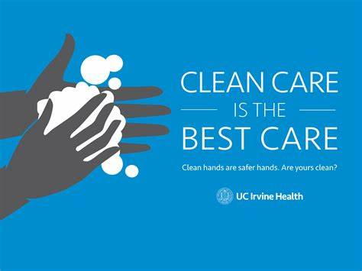

|  |  |
| --- | --- |
| TOPICS | PAGE NO |
| 1. Introduction to community service | 08-10 |
| 1. Activities conducted | 11-19 |
| 3.Conclusion  Annexure  Bibliography | 20  21-23  24 |

**CHAPTER 1**

INTRODUCTION TO COMMUNITY SERVICE

**DEFINING**

Community Service Project involves students in community development and service activities and applies the experience to personal and academic development. • Community Service Project is meant to link the community with the college for mutual benefit.

Some students are required to complete community service as part of a class requirement in order to graduate high school or become a member of certain organizations, such as the

National Honour Society.ordered to do so by a judge.

**What Are Examples of Community Service?**

There are hundreds of ways to participate in community service, depending on your skills and interests. Some common community service examples include Working with schoolchildren: Tutoring children after school, collecting school supplies to donate, planting a school garden.

**Working with senior citizens**: Visiting residents of a retirement centre, delivering meals to senior citizens, driving them to appointments.

**Improving the environment:** Holding a recycling contest, planting trees, creating a new trail at a nature centre. Helping low-income people: Passing out food at a soup kitchen, collecting used clothes to be donated, making first aid kits for homeless shelters.

**Collect Food**: Contact your local food bank and they will provide you with the necessary information and materials to have a food drive. For example, the Food Bank of

Delaware provides a food drive organization kit, most wanted food list, and more. Encourage people to donate their favourite food items. You can even offer prizes to individuals who donate the most!

**Recycling Program**: Starting a recycling program is a big task but a worthwhile one. Here’s a great guide to get you started. When you recycle, those items can be turned into

amazing things, like the Green Guardian coat, made from recycled PET plastic bottles.

Community Garden: A community garden is a great way to bond with your community and provide healthy food. You may be able to identify a sponsor to help get your

garden started. Consider making a garden just for children, so they can learn about the process of gardening. It is a great educational opportunity.

**Clean up**: A community clean-up will improve the look of your neighbourhood or park and inspire people to keep the space looking great. Hosting a potluck after is wonderful

way to celebrate this community achievement!

**Blood drive**: Every two seconds, someone in the U.S. needs blood. By hosting a blood drive, you and your community can make a real difference. The American Red Cross provides planning assistance, recruitment tools, equipment, supplies, and a trained staff to screen and

collect donations safely.

Direct:-You can develop direct service activities where students interact with the recipients of service or

the physical environment they have targeted for improvement. You and your chapter can volunteer at a food

kitchen to serve community mem-bers in need. Or perhaps you can work with your communitysenior center

to create an adopt-a-grandparent program that lasts beyond FFA Week.

In-Direct:-If you don’t have the ability to come in direct contact with the beneficiaries of service, you can

organize an indirect service activity where students channel resources to a problem but do not interact with

those being served. This can include organizing a canned food drive to donate to a food pantry in a

neighboring community or participating in a community beautification project.

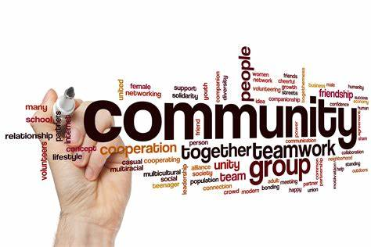

Direct:-You can develop direct service activities where students interact with the recipients of service or

the physical environment they have targeted for improvement. You and your chapter can volunteer at a food

kitchen to serve community mem-bers in need. Or perhaps you can work with your communitysenior center

to create an adopt-a-grandparent program that lasts beyond FFA Week.

In-Direct:-If you don’t have the ability to come in direct contact with the beneficiaries of service, you can

organize an indirect service activity where students channel resources to a problem but do not interact with

those being served. This can include organizing a canned food drive to donate to a food pantry in a

neighboring community or participating in a community beautification project.

Direct:-You can develop direct service activities where students interact with the recipients of service or

the physical environment they have targeted for improvement. You and your chapter can volunteer at a food

kitchen to serve community mem-bers in need. Or perhaps you can work with your communitysenior center

to create an adopt-a-grandparent program that lasts beyond FFA Week.

In-Direct:-If you don’t have the ability to come in direct contact with the beneficiaries of service, you can

organize an indirect service activity where students channel resources to a problem but do not interact with

those being served. This can include organizing a canned food drive to donate to a food pantry in a

neighboring community or participating in a community beautification project.

Direct:-You can develop direct service activities where students interact with the recipients of service or

the physical environment they have targeted for improvement. You and your chapter can volunteer at a food

kitchen to serve community mem-bers in need. Or perhaps you can work with your communitysenior center

to create an adopt-a-grandparent program that lasts beyond FFA Week.

In-Direct:-If you don’t have the ability to come in direct contact with the beneficiaries of service, you can

organize an indirect service activity where students channel resources to a problem but do not interact with

those being served. This can include organizing a canned food drive to donate to a food pantry in a

neighboring community or participating in a community beautification project.

Direct:-You can develop direct service activities where students interact with the recipients of service or

the physical environment they have targeted for improvement. You and your chapter can volunteer at a food

kitchen to serve community mem-bers in need. Or perhaps you can work with your communitysenior center

to create an adopt-a-grandparent program that lasts beyond FFA Week.

In-Direct:-If you don’t have the ability to come in direct contact with the beneficiaries of service, you can

organize an indirect service activity where students channel resources to a problem but do not interact with

those being served. This can include organizing a canned food drive to donate to a food pantry in a

neighboring community or participating in a community beautification project.

Direct:-You can develop direct service activities where students interact with the recipients of service or

the physical environment they have targeted for improvement. You and your chapter can volunteer at a food

kitchen to serve community mem-bers in need. Or perhaps you can work with your communitysenior center

to create an adopt-a-grandparent program that lasts beyond FFA Week.

In-Direct:-If you don’t have the ability to come in direct contact with the beneficiaries of service, you can

organize an indirect service activity where students channel resources to a problem but do not interact with

those being served. This can include organizing a canned food drive to donate to a food pantry in a

neighboring community or participating in a community beautification project.

Direct:-You can develop direct service activities where students interact with the recipients of service or

the physical environment they have targeted for improvement. You and your chapter can volunteer at a food

kitchen to serve community mem-bers in need. Or perhaps you can work with your communitysenior center

to create an adopt-a-grandparent program that lasts beyond FFA Week.

In-Direct:-If you don’t have the ability to come in direct contact with the beneficiaries of service, you can

organize an indirect service activity where students channel resources to a problem but do not interact with

those being served. This can include organizing a canned food drive to donate to a food pantry in a

neighboring community or participating in a community beautification project.

Direct:-You can develop direct service activities where students interact with the recipients of service or

the physical environment they have targeted for improvement. You and your chapter can volunteer at a food

kitchen to serve community mem-bers in need. Or perhaps you can work with your communitysenior center

to create an adopt-a-grandparent program that lasts beyond FFA Week.

In-Direct:-If you don’t have the ability to come in direct contact with the beneficiaries of service, you can

organize an indirect service activity where students channel resources to a problem but do not interact with

those being served. This can include organizing a canned food drive to donate to a food pantry in a

neighboring community or participating in a community beautification project.

Direct:-You can develop direct service activities where students interact with the recipients of service or

the physical environment they have targeted for improvement. You and your chapter can volunteer at a food

kitchen to serve community mem-bers in need. Or perhaps you can work with your communitysenior center

to create an adopt-a-grandparent program that lasts beyond FFA Week.

In-Direct:-If you don’t have the ability to come in direct contact with the beneficiaries of service, you can

organize an indirect service activity where students channel resources to a problem but do not interact with

those being served. This can include organizing a canned food drive to donate to a food pantry in a

neighboring community or participating in a community beautification project.

Direct:-You can develop direct service activities where students interact with the recipients of service or

the physical environment they have targeted for improvement. You and your chapter can volunteer at a food

kitchen to serve community mem-bers in need. Or perhaps you can work with your communitysenior center

to create an adopt-a-grandparent program that lasts beyond FFA Week.

In-Direct:-If you don’t have the ability to come in direct contact with the beneficiaries of service, you can

organize an indirect service activity where students channel resources to a problem but do not interact with

those being served. This can include organizing a canned food drive to donate to a food pantry in a

neighboring community or participating in a community beautification project.

WAYS TO PARTICIPATE IN COMMUNITY SERVICE

* Volunteer at your local library.

* Volunteer to chaperone a field trip.

* Volunteer with a local non-profit.

* Volunteer at an animal shelter.

* Volunteer at a community centre.

* Volunteer as a lifeguard.

* Volunteer to be a crossing guard.

* Volunteer to do social media for a local org.

CHAPTER 2

ACTIVITIES CONDUCTED

At first, we contacted our locality volunteer to know the population in our surrounding area and collected information of people.

We started to collect information of people about their health and hygienic conditions.

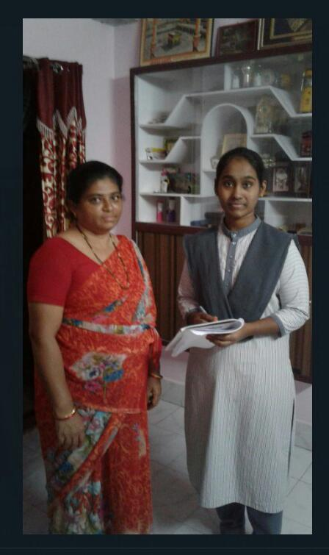

We approached people in our localities and asked some questions.

* Which type of food your family prefers?

[brown rice/white rice]

* Does your family follow yoga / physical fitness regularly?

[ walking/ exercise/]

* Does your water containers are opened or closed?
* Do your family members use masks and sanitizers while going out?
* Do the GMC workers will come regularly to clean the garbage?
* Do you separate the garbage?

[dry waste/ wet waste]

* Do you wash your clothes regularly, if so, then with which water?

[soft water/hard water]

* What type of water your family prefer to drink &how will you purify the water

[normal water/boiled water/mineral water /copper purified water]

* If you have children less than 5 years [ does he/she vaccinated with polio drops]?
* Are there any diabetic patients in your family?
* Which type of medical treatment your family prefers?  
  [ ayurvedic/English medicine]
* Will you use any mosquito repellents at nights?
* Are there any plants in your home?  
  [for pure air]
* Will your family take any dairy products? Which consists of calcium, lactose …etc [milk, curd]
* Does your family go for regular medical check-ups?

In this way, we questioned people, and we gathered answers of people.

We got to know the answers to the above questions.

**HEALTH**

Food- Brown rice is more nutrient-dense than white rice. Because of this, brown rice may help reduce blood sugar levels and aid in weight management efforts. However, white rice is good for those with certain digestive issues who cannot digest fibre-rich foods well.

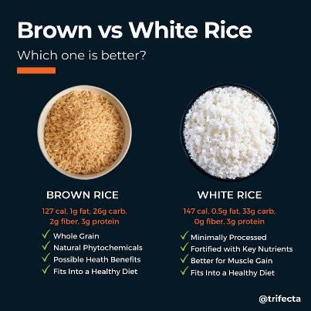

Fitness-Walking, lifting weights, doing chores – it’s all good. Regardless of what you do, regular exercise and physical activity is the path to health and well-being. Exercise burns fat, builds muscle, lowers cholesterol, eases stress and anxiety, lets us sleep restfully

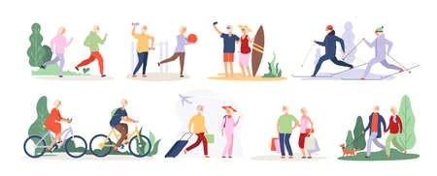



Water-people are now-a-days preferring cane water. But water which stores in plastic harms our health and people have to use pot water instead of fridge water which is goof for health

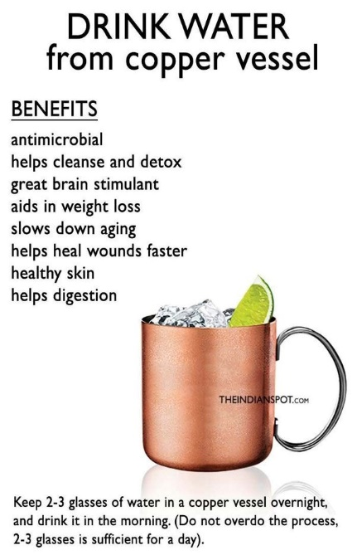

Plantation- It’s good to grow plants in our houses which gives pure air and can grow vegetables



Medical check-up- People have to take a monthly check-up or6 months to know our body conditions like dental, eye, CBC, LPT,CHT,etc and have taken precautions if there are any mild changes in our reports

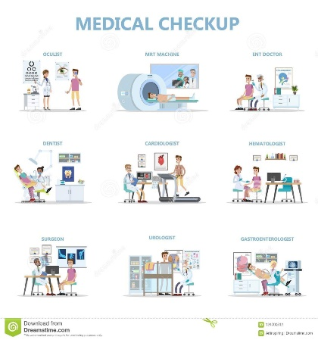

Dairy products- people have to take some dairy products, like [ milk, yogurt, cheese, lactose-free milk and fortified soy milk and yogurt.] which helps to increase rich in calcium, vitamin B-2, vitamin B-12, potassium, and magnesium.



Hereditary diseases- now-a-days, it’s become common in all families in getting hereditary disease from their ancestors.

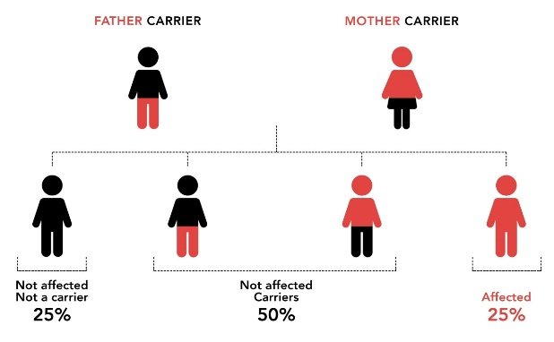

So people have to be careful and take care and have to balance their health conditions regularly

**HYGIENE**

Cleanliness

Cleanliness is one of the most important elements of good health. Thus, it is an important hygiene habit to keep yourself and your surroundings neat and clean. Whenever there is dirt, there are germs that thrive in it. Also, the dirt is light in air and thus it moves around in the air. So, a dirty man is often the one that is attacked easily with various diseases.

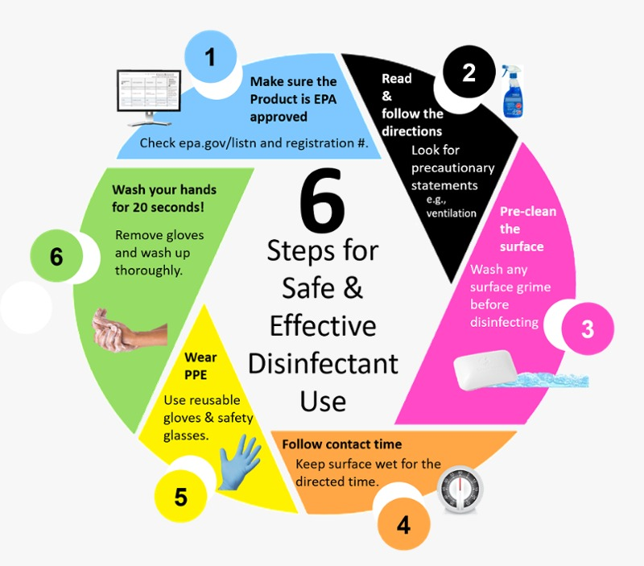

Sanitation protocols-

* Cleaning Surfaces.

* Disinfecting Surface

* Rinsing Surfaces. ...
* Washing hands before taking or preparing food.

Water& Air - Clean air and safe water are prerequisites for health. Poor air or water quality can be particularly detrimental to vulnerable populations such as the very young, the elderly, and those with chronic health conditions.

Types of personal hygiene-

There are many types of personal hygiene. The following list is a good starting point for someone looking to build a personal hygiene routine:

DENTAL

Dental hygiene involves more than just having white teeth. A good dental hygiene routine can help prevent issues such as gum disease and cavities. It can also prevent bad breath.

Body

Several million sweat glands cover the human body. When bacteria break down sweat, the process creates a smell or body odour. Washing the body will help prevent skin irritation, as well as removing the bacteria that cause body odour. Washing the hair removes oil and keeps a person looking clean and fresh.

Hand washing

Regular hand washing is one of the best ways to avoid spreading communicable diseases.

NAILS

Fingernails may harbour dirt and germs, contributing to the spread of bacteria. It is easier for dirt and germs to collect under longer nails, so keeping them short can help reduce the risk of spreading infections.

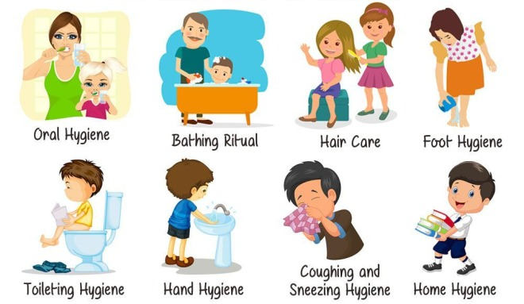

So these are the topics we have discussed with people.

And we gathered their responses in the following way

* Most of the People are taking the white rice
* Most of the People are going to walk regularly
* Most of the People are not going for any regular medical check-ups
* Only a few are taking the dairy products
* Some are taking the malts which gives energy
* Only a few are following hygienic measures.
* Most of the people are growing plants in their houses

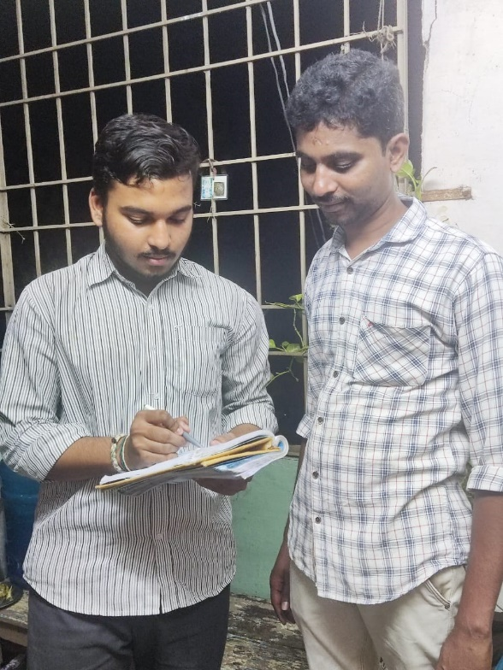

And at last, we suggested them a few health and hygienic tips to lead a healthy life.

We analysed how people health conditions exists and what type of lifestyles they are maintaining towards healthy life.

Some of the health and hygienic tips which we have suggested to people are the following:

* Do yoga / walking regularly
* It’s good to take a glass of hot water in the early morning
* Maintain your surroundings in neat and clean
* We should aware our body conditions and have to take steps in early stage of illness
* People must take the food which improves their immunity levels.
* People can use moisturisers and sunscreen lotions for a healthy skin
* Wash your hands before taking food
* Covering your mouth and nose with a tissue when sneezing or coughing
* Store foods appropriately both before and after cooking
* Make a good sleep environment
* People should limit alcohol and caffeine if they are habituated.
* Clean surfaces regularly
* Maintain your personal hygiene
* People who are diabetic or B.P, must check their levels regularly to know they are in controlled conditions or not.

**CONCLUSION**

As our team started this, Community service. We thought it was easy to do and there will be no problems we are going to phase.

But we were wrong it was not easy to do community service, but we didn't quit. By doing this community service we have learned how to be patience and how to talk/interact with the people

As the day 1 we started, the way of challenges is different from the other day. Each day has different challenges and out comes

The people we contacted while doing this service have been patience and gave the answers what we have questioned them with a polite manner, and they suggested us few questions too. The way of interaction with us very good from people, our team have learned so much from community/society

Even not only in service, but daily me and my team will try our level best to help people and share knowledge to them

At last We got to know about how people health conditions exists and how they are aware about all the these topics of health and hygienic.

ANNEXURE

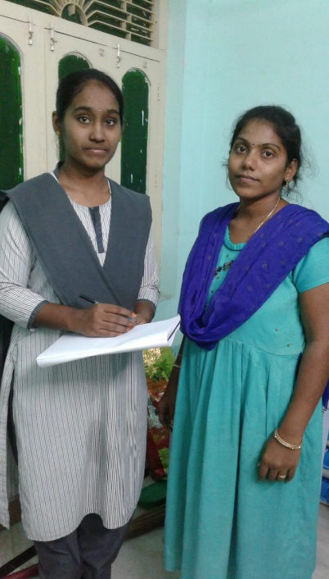

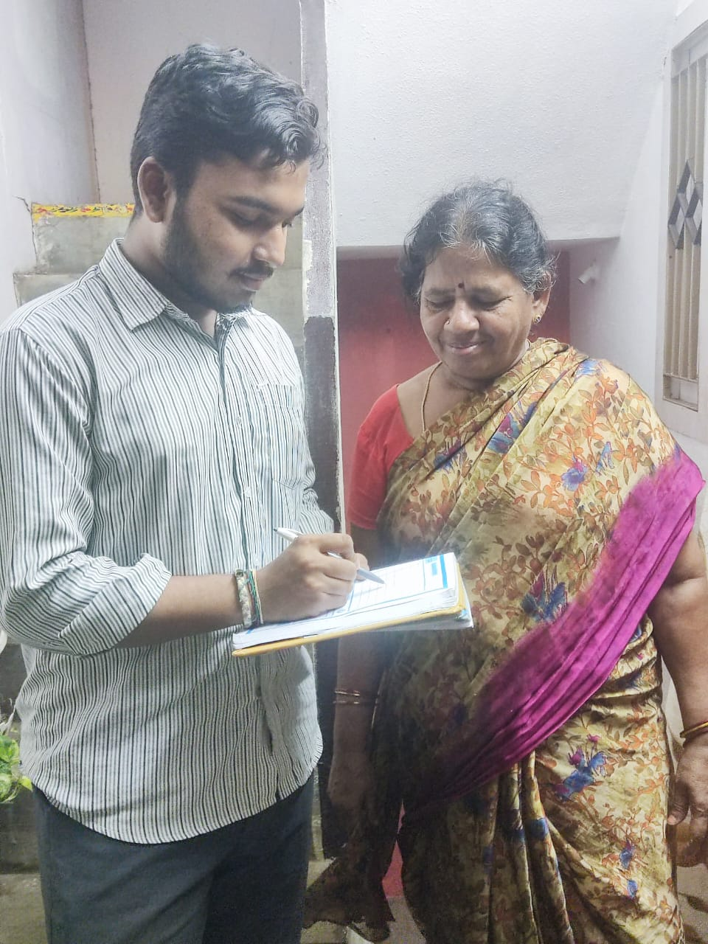

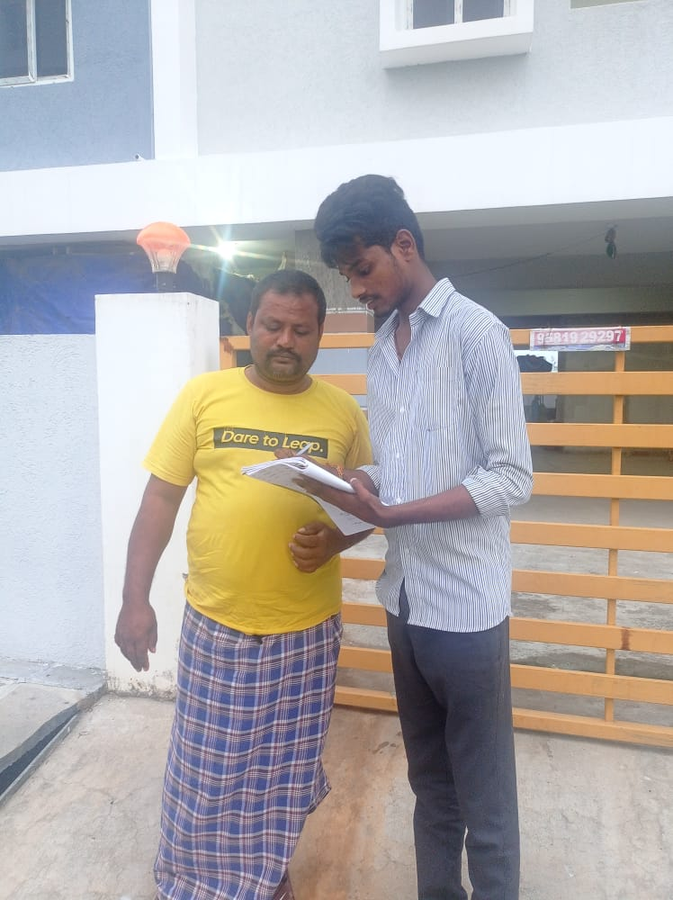

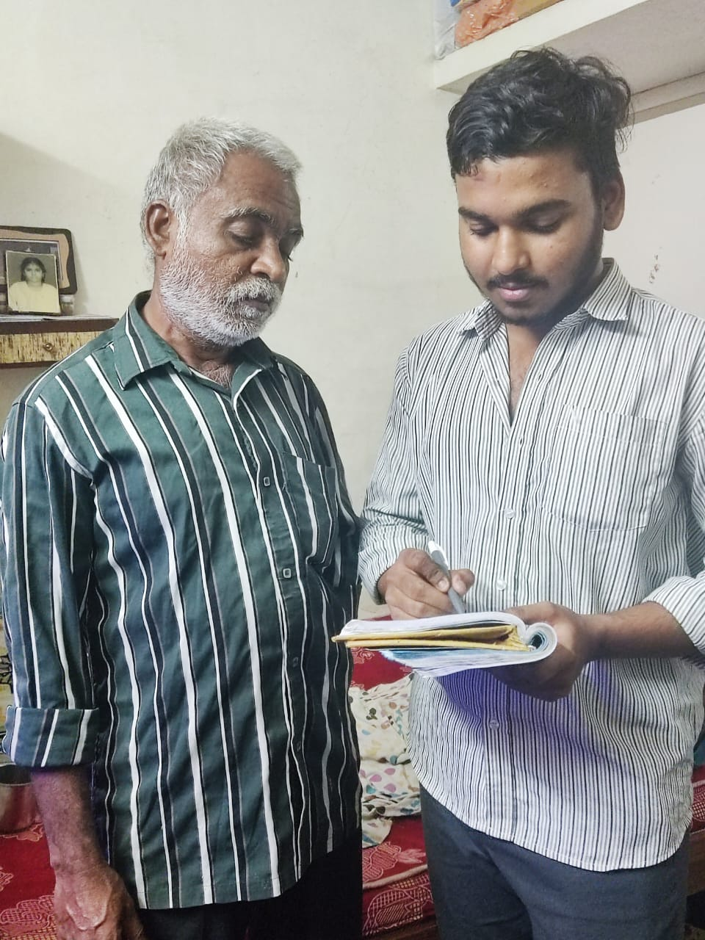

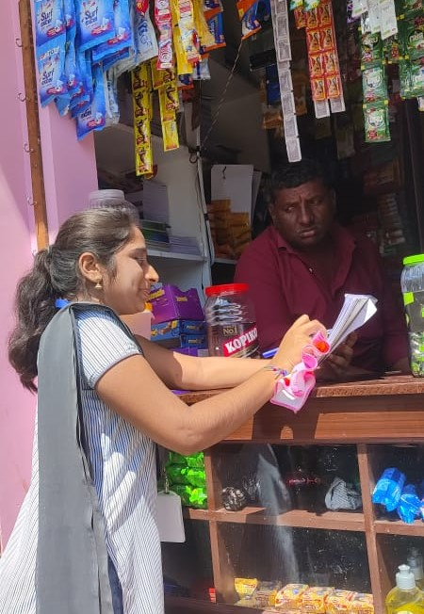

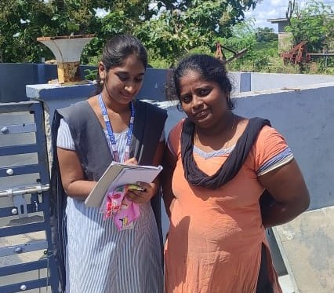

**BIBILOGRAPHY**

BOOKS

* Health Hygiene and Nutrition Perception and Practices by Acharya, Sankar Kr & Rama Das & Minati Sen, Satish Serial Publishing House
* HEALTH AND HYGIENE (WITH ANATOMY AND PHYSIOLOGY) by Swami Sivananda
* Do We Care: India’s Health System by K. Sujatha Rao
* Occupational Health and Safety by SK Haldar

NEWSPAPERS AND MAGAZINES

* Health & Nutrition Magazine.
* Men's Health Magazine.
* Women's Health Magazine.
* B Positive Magazine.
* Food & Health Magazine.
* Psychology Today Magazine.
* Life Positive Magazine.
* Diabetes Health Magazine.

INTERNET

* <http://www.bccdc.ca>
* <http://www.foodsafe.ca>
* [www.halton.ca/cms/one.aspx?portalId=8310&pageId=37644](http://www.halton.ca/cms/one.aspx?portalId=8310&pageId=37644)
* <http://www.inspection.gc.ca/about-the-cfia/newsroom/food-safety-system/haccp/eng/1346306502207/1346306685922>
* <http://www.bclaws.ca/civix/document/id/complete/statreg/08028_01>
* <https://www.credihealth.com/blog/health-and-hygiene/>